**GENERAL HUMAN BIOLOGY**

**TASK 3 – HEART DISSECTION PRACTICAL – MARKING KEY**

**Dissection:**

* Locate the apex of the heart and measure the length of the heart from top to bottom.

Record the length: __________________ (1 mark)

* Appropriate measurement with units

**Draw a diagram of the valves in the space below** (1 mark each point TOTAL = 3 marks)

* Use of pencil, Scientific drawing, Accurate (3)
* Same as above, some error (2)
* Attempt (1)

1. What is the purpose of these valves? (1 mark)

* Keep blood flowing in one direction / prevent backflow of blood

1. What is different about the left ventricle compared with the right ventricle? (1 mark)

* Left ventricle wall thicker than right ventricle wall

**Questions:**

1. Label the following diagram of the heart. Using coloured pencils, colour parts of the diagram of the heart and use arrows to show the flow of deoxygenated blood (blue) and oxygenated blood (red) through the heart. (13 marks)

* Each labelled component correct – 1 mark each TOTAL – 9 marks
* Correct colouring of oxygenated and deoxygenated blood heart chambers – 1 mark each TOTAL = 2 marks
* Correct direction of flow of blood – 2 marks

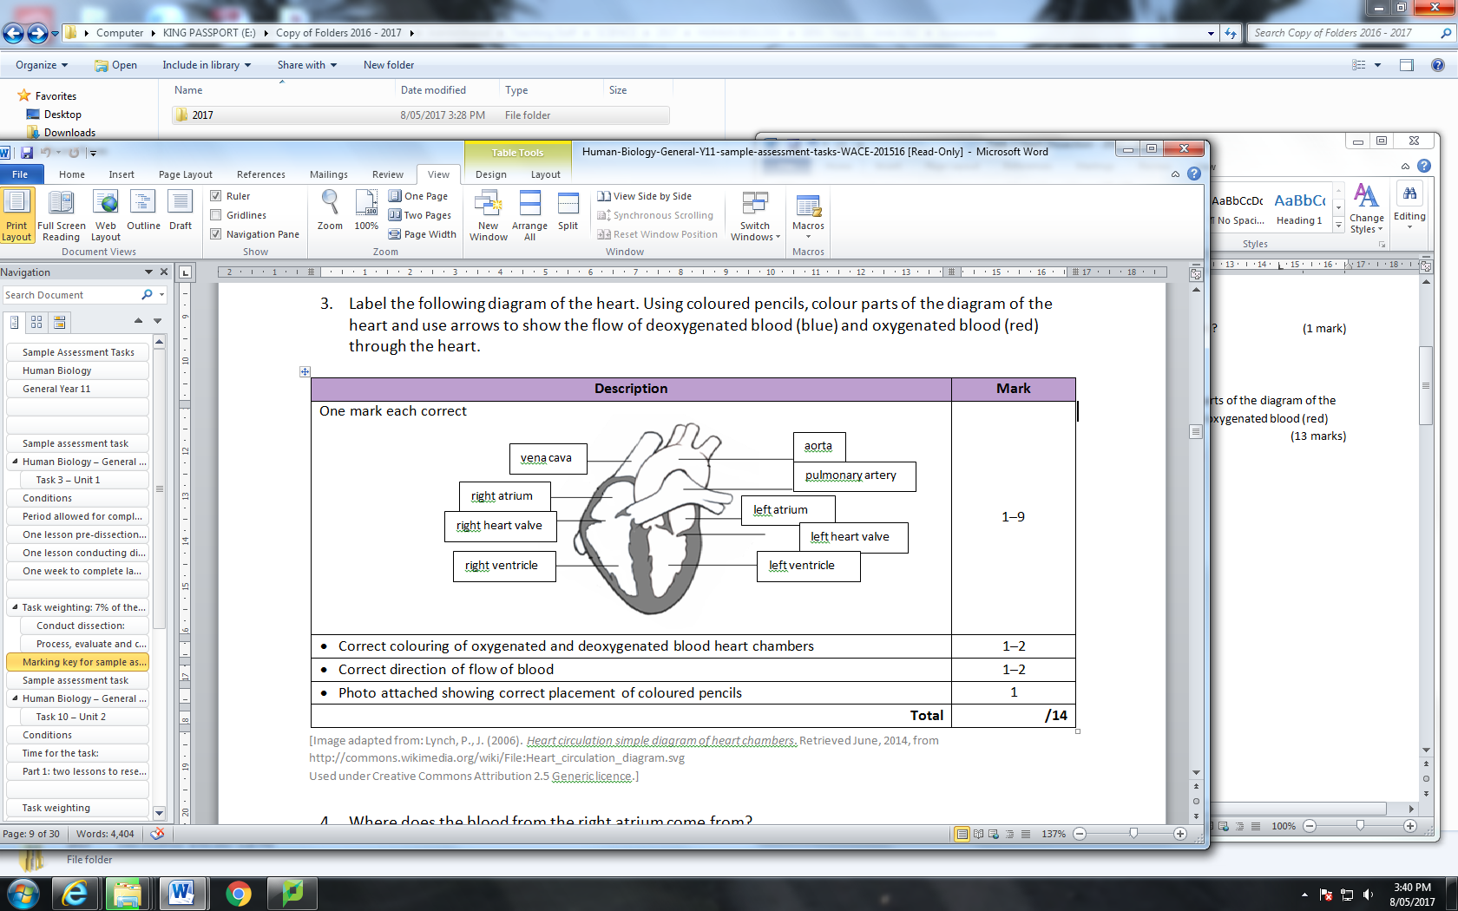

1. Where does the blood from the right atrium come from? (1 mark)

* The body

1. Where does the blood from the right ventricle go to? (1 mark)

* The lungs

1. Where does the blood from the left atrium come from ? (1 mark)

* The lungs

1. Where does the blood from the left ventricle go to? (1 mark)

* The body

1. The heart is known as a double pump. Explain why it is known as a double pump.

(1 mark each TOTAL = 3 marks)

* First pump – blood moves from atria to ventricles
* Second pump – blood goes from ventricles to lungs and body
* Reference to double circulatory system (pulmonary and body)

1. Are there any valves in other parts of the circulatory system? If so, where?

(1 mark each point TOTAL = 2 marks)

* Yes
* In the veins

1. Compare the valves separating the right chambers of the heart with the valves separating the left chambers of the heart. (1 mark per point TOTAL = 2 marks)

* Right valve has three cusps (flaps)
* Left valve has two cusps (flaps)

1. When comparing the walls of the ventricles, why is the wall of the left ventricle different from the wall of the right ventricle? (1 mark per point TOTAL = 2 marks)

* Left ventricle needs more strength to pump blood further around the body
* While the right ventricle only needs to pump blood to the nearby lungs

1. Describe the pathway that one red blood cell takes from the time it enters the superior vena cava until the time it leaves the aorta ? (Any 8 points TOTAL = 8 marks)

* Enters right atrium
* Passes through tricuspid valve (must mention this, not just AV valve)
* Enters right ventricle
* Leaves via pulmonary artery going to lungs
* Becomes oxygenated/ undergoes gas exchange in lungs and returns
* Via pulmonary veins
* Enters left atrium
* Passes through bicuspid valve (must mention this, not just AV valve)
* Enters left ventricle
* Passes through semilunar valve
* Aorta delivers oxygenated blood cell to body